Monday, February 23, 2026

Brad Boland, Planning Manager
Town of Castle Rock
100 N Wilcox St
Castle Rock, CO 80104

RE: 512 N Wilcox LLC Pre-Application Cover Letter

Dear Mr. Boland,

Please accept this cover letter as additional, supporting information for our Pre-Application.

This project involves the renovation and improvement of the existing property, including both interior and exterior enhancements consistent with the Town’s development standards and community character objectives.

Preliminary stie and building plans have been drafted by Echo Architecture and are included for conceptual review. These plans outline the anticipated interior layout, building modifications, circulation, and exterior concepts. We are including preliminary interior and exterior renderings to provide a visual representation of the proposed aesthetic direction and overall design intent.

The project scope consists of interior demolition and renovation, along with exterior façade improvements and associated site refinements. Interior demolition activities are beginning in preparation for the full renovation process, while we move through the Town’s review and entitlement procedures. All work will comply with applicable permitting requirements and building codes.

We look forward to setting a meeting time to discuss further.

Please contact me directly for additional information.

Sincerely,

Angela Vencill
Director of Finance/HR

cc: Jed Kenzy, Innovative Business Solutions, Managing Partner Mike Trede, Innovative Business Solutions, Managing Partner

INTERIOR CONCEPTS

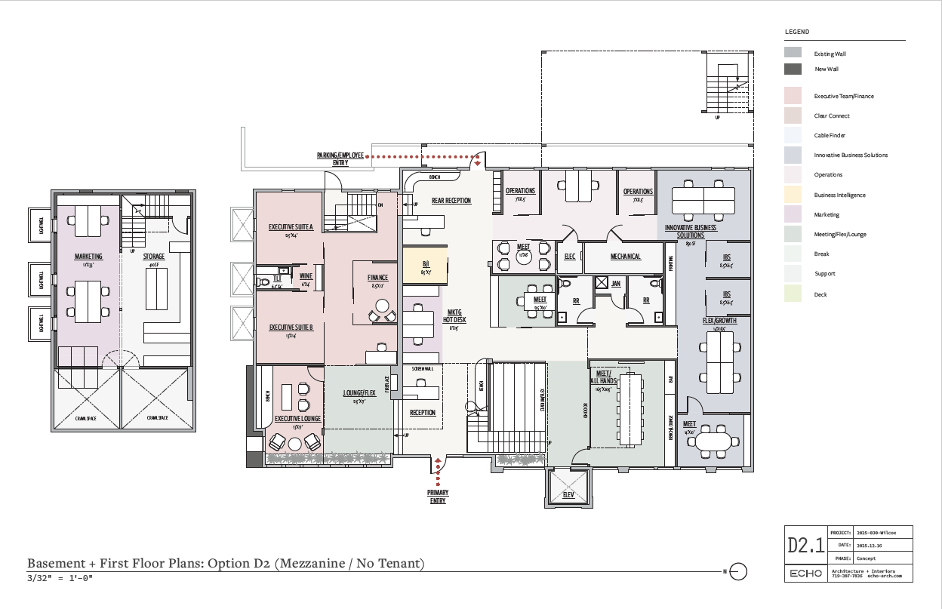

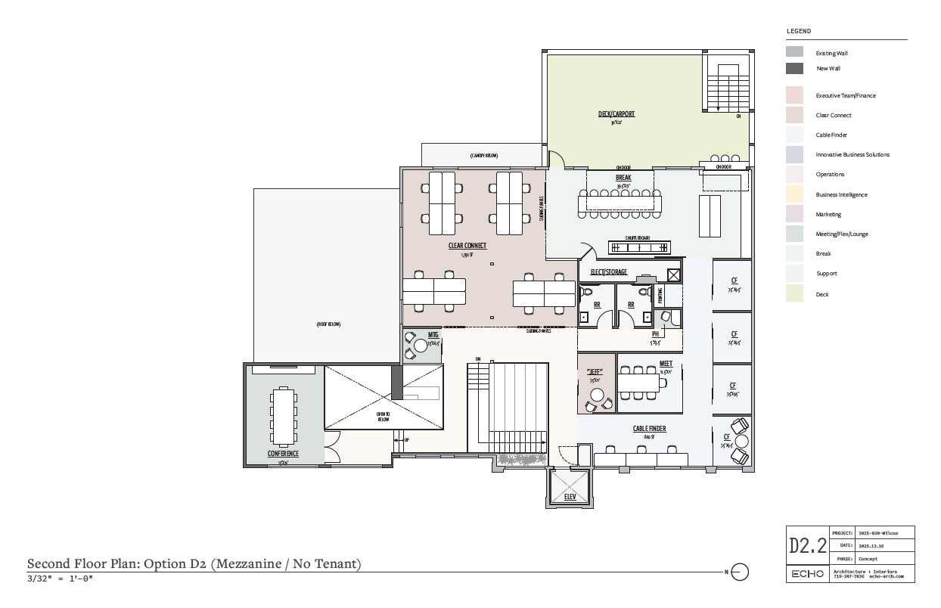

EXTERIOR CONCEPTS

