May 30, 2024
BrieAnna Simon
Development Services, Senior Planner
Town Hall, 100 N. Wilcox St,
Castle Rock, CO 80104
(720)733-3566

Dear Ms. Simon,

Below is a narrative encompassing our revisions to the Wellspring Community Center PD Plan submittal:

- Zoning Regulations:
  - Revised regulations for Wellspring Community to be the primary use.
  - Intent has been added to each of the planning areas
  - Church /Office as a secondary use
    - Church /Office to be utilized on Sundays and during the week at the discretion of Wellspring Community
    - Included provision prohibiting amplified sound / amplified church services outdoors
    - Added additional nursery use definition
  - Reformatted and revised Overall Project Standards to be aligned with Town of Castle Rock Land Development Code
    - Removed duplication(s)
- Concept Utility Letter has been updated
  - TMU permit will be required. This will be started with CDs and finalized before construction
  - Commercial Business Building Permit/Grease Interceptor Letter will be included with the SDP phase
- Drainage Report is Phase 1
  - Water Quality Certification Form filled out without exact areas defined
  - Permanent WQ Worksheet filled out without exact areas defined
- PD Plan
  - Legal Description has been updated per updated title work
  - Zoning Description Chart Revised
  - Land Use Summary Revised
  - Suveyor’s Signature Block has been updated
  - Lien Holder has been removed
  - Title Certification has been updated
  - Town Council Signature Block has been updated
  - Douglas County Clerk and Recorder’s Signature Block has been updated
  - Removed Town of Castle Rock Ownership Block
  - Parking calculations have been removed
  - Utilities have been revised to show approximate location of potential connection points for future utilities
  - Dashed line is shown for potential sanitary sewer connection
  - Aerial has been removed
  - Water Quality and Detention pond information has been removed
    - Area is labeled as potential area for Water Quality and Detention
  - Planning Areas have been clearly identified
  - Parcel A, B, and C point of beginning has been added
  - Bearings and distances have been updated per updated legals and title
  - Property boundary has been revised to thick solid black line
  - Plan has been revised to be high level zoning map
  - PD Zoning Regulations have been updated
- Title has been updated and included
- Severed Mineral Right notification affidavit has been included
- Traffic Impact Study
  - Executive Summary has been added
  - Report was revised to reflect new traffic counts
  - Information regarding the existing bicycle lane has been included
  - Additional ADT information has been added to the report
  - Intersection Operation Tables have been revised to Town Standard
  - Revised to show ¾ access point at Wolfensberger
    - Traffic from development to the East has bene added to the background (and total) analysis. Figures and tables have been updated accordingly
  - Figure 11 has been updated to account for additional employee trips from the revised generation table
  - Report has been revised to account for traffic from Hillside development (immediately North of the project), the Brickyard development, and the adjacent church
    - Traffic from adjacent developments have been incorporated into the report
  - Revised to account for street improvements at intersection #3, #4
  - Removed second southbound left turn lane
  - Include improvements to Prairie Hawk Dr. north and south of Wolfensberger to be 4 lane arterial

Sincerely,
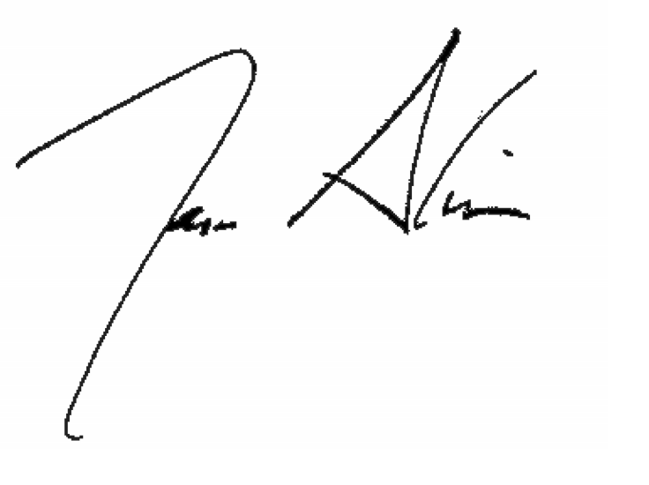
Jason Alwine, PLA
Director of Landscape Architecture
Matrix Design Group

