

DEVELOPMENT SERVICES – ZONING DIVISION

100 N. Wilcox Street Castle Rock, CO 80104 720-733-3557 • zoning@CRgov.com

Meeting Date: October 2, 2025

AGENDA MEMORANDUM
To: Board of Adjustment

From: Tammy King Zoning Manager

Title: Request for Approval of Variance from the Rear Yard Setback
PD (Planned Development)

Subject Property: 3962 SCARLET OAK COURT

Summary
The purpose of this staff memorandum is to seek action by the Board of Adjustment on a request by
Brian and Megan Peterson for variance from the minimum required rear setbacks for a deck in the PD
Zone (Single Family). The subject property is addressed as 3962 Scarlet Oak Court, also known
as Lot 44, Block 1 Meadows 11th Flg, Parcel 6

The applicant has submitted a site plan, which will constitute a maximum 10’ rear yard variance to
the minimum required twenty foot (20’) rear yard setback for a deck cover in the PD zone district, if
approved by the Board. This variance, if approved, would allow a maximum rear yard setback of 10’
for the new deck cover, which would be outside the 10’ rear utility easement.

Discussion
- The rear yard backs to Tract F (17.68 acres), which is owned by the Meadows Neighborhood Company (HOA), and also adjoins Meadows Boulevard
- The lot is irregular in shape, especially the rear property line.
- The HOA has approved the deck cover
- The deck is existing and has recently also been approved by the HOA. The owner is only constructing a cover over a portion of the deck.
- We have had no neighbor opposition
- CORE has approved the existing deck and stairs within the easement and no approval for the cover is required, as there is no encroachment into the rear 10’ easement.

AERIAL:

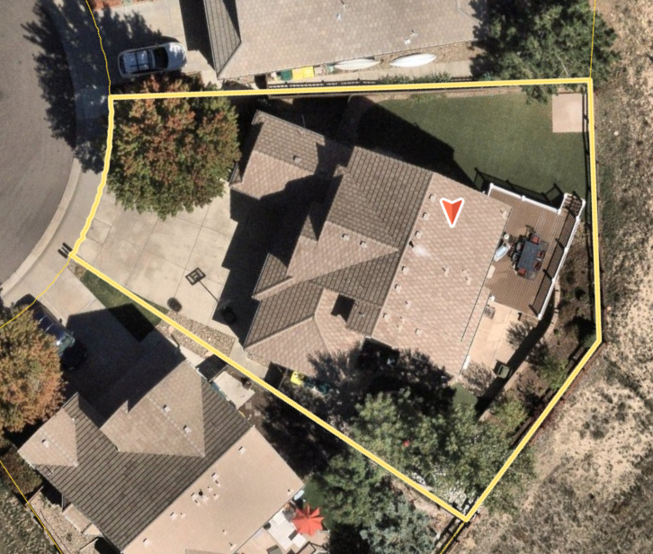

PLOT PLAN:
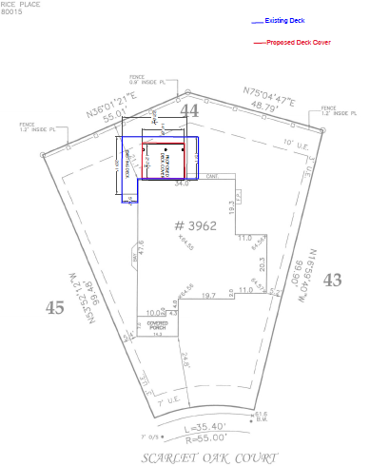

DECK COVER PLAN:
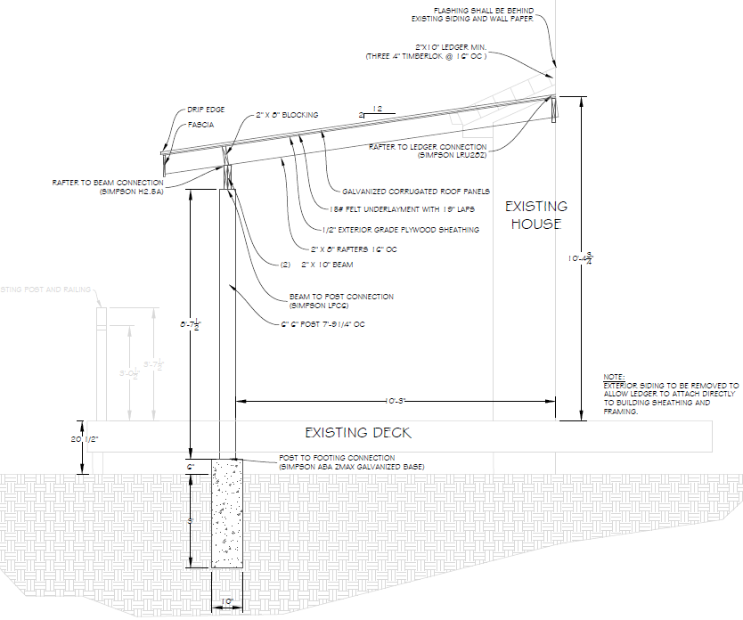

SOUTH ELEVATION (REAR):

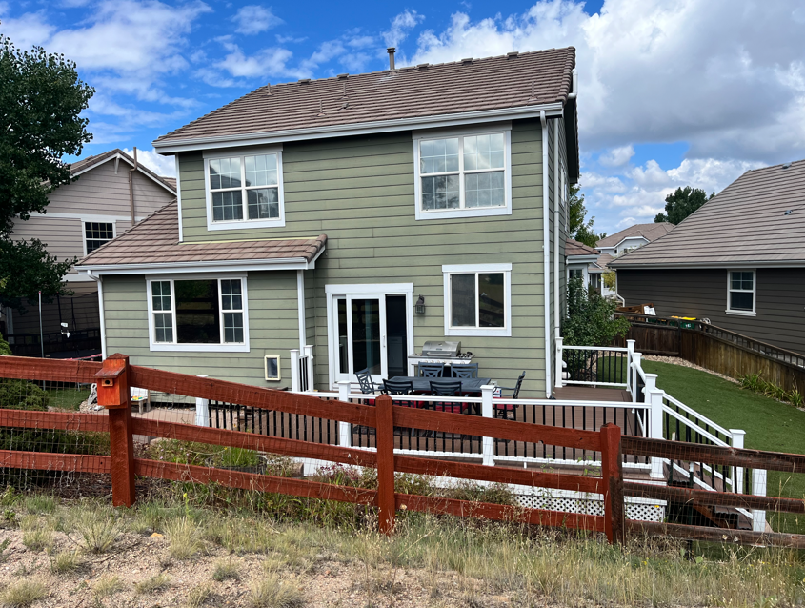
EAST ELEVATION:

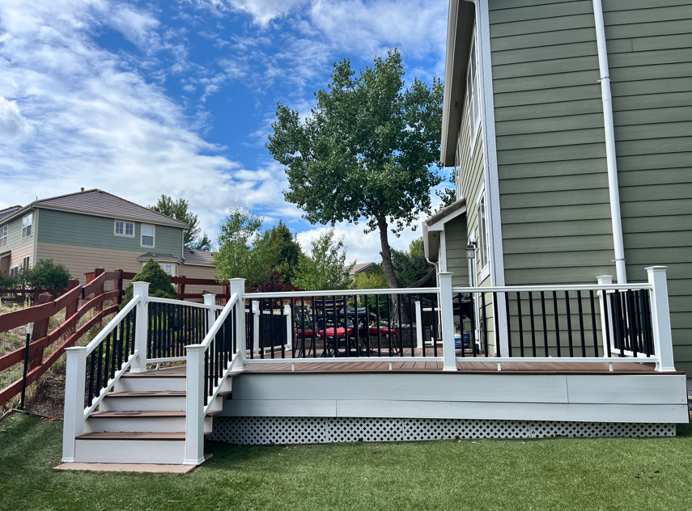

WEST ELEVATION:

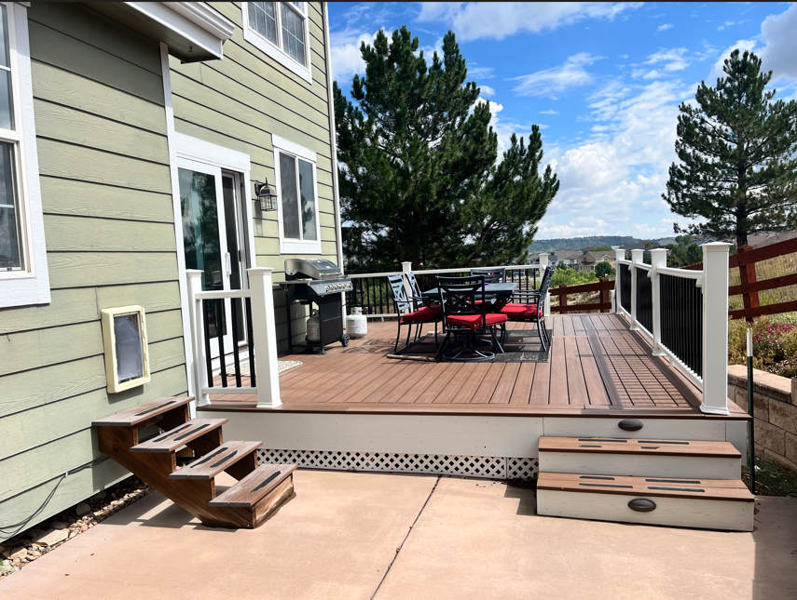

Town of Castle Rock Municipal Code 17.06.020 Powers and Duties
B. Variances
- Following proper notice; the Board shall hear and decide an appeal on specific cases for a variance to the following: Minimum rear yard.

- In making its decision on a variance application, the Board shall consider the following and find:
  - The strict enforcement of the provisions of this Code will result in practical difficulties or unnecessary hardship to the applicant, inconsistent with the intent and purpose of this Code;
  - The practical difficulties or unnecessary hardship were not created by the applicant;
  - Unique physical conditions or exceptional topography exist on the subject property and similar unique conditions do not exist on neighboring properties;
  - The property is unable to be reasonably developed in conformity with the provisions of this Code due to unique physical conditions or exceptional topography;
  - The variance, if granted, will not substantially alter the character of the neighborhood in which the property is located, or impair the use or development on adjacent property; and
  - The variance, if granted, will not create an adverse effect on public health, safety and welfare or cause harm to adjacent properties.
- The Board may impose reasonable conditions on the grant of a variance. In addition, upon approval of a variance, the Board shall determine whether the variance is limited to the condition existing on the property at the time of approval, or whether the variance runs with the land regardless of whether the conditions on the property change.

- The decision of the Board shall be final, subject to judicial review.

Staff Findings
- The strict enforcement of the provisions of this Code will result in practical difficulties or un-necessary hardship to the applicant, inconsistent with the intent and purpose of this Code:

Staff finds that strict enforcement of the Code may result in practical difficulties contrary to the intent and purpose of the Code due the irregular shape of the lot and the lot backs to open space and then Meadows Boulevard.
- The practical difficulties or unnecessary hardship were not created by the applicant:

Staff finds the practical difficulties or unnecessary hardship was not created by the applicant.
- Unique physical conditions or exceptional topography exist on the subject property and similar, unique conditions do not exist on neighboring properties:

Staff finds that unique physical conditions may exist for this property due to the irregular shape of the lot and that the lot backs to open space and Meadows Boulevard;

- The property is unable to be reasonably developed in conformity with the provisions of this Code due to unique physical conditions or exceptional topography:

Staff has information to support the concept that unique physical conditions or exceptional topography exist on the subject property that would prevent the property from being developed in conformity with the provisions of the current Town code due to the irregular shape of the lot and backing to open space and Meadows Boulevard;
- The variance, if granted, will not substantially alter the character of the neighborhood in which the property is located, or impair the use or development on adjacent property:

Staff finds that the variance, if granted, will not substantially alter the character of the surrounding neighborhood; and the construction of the deck cover over an existing deck on the single-family residence will generally be harmonious with other surrounding neighboring properties;
- The variance, if granted, will not create an adverse effect on public health, safety and welfare, or cause harm to adjacent properties:

Staff finds that the variance, if granted, will not create an adverse effect on public health, safety and welfare or cause harm to adjacent property if the proposed new construction meets all current building code requirements.

Staff Recommendation
Staff recommends APPROVAL due to:
- The lot is irregular in shape
- The lot backs to open space and Meadows Blvd
- HOA has approved the request for the previously built deck and deck cover
- No objection from neighbors
- CORE has approved the existing previously constructed deck and stairs located in the
rear 10’ utility easement
Motion Options

In accordance with criteria as stated in the Town of Castle Rock Municipal Code Section
17.06.020 BOARD OF ADJUSTMENT:
Option 1
I MOVE THAT THE BOARD OF ADJUSTMENT APPROVE Brian and Megan Peterson’s request for approval of a variance from the minimum required rear setbacks to construct a deck cover over an existing deck on an existing single-family residence, as shown in the attached plot plan, in the PD zone; based upon:

Option 2
I MOVE THAT THE BOARD OF ADJUSTMENT DENY Brian and Megan Peterson’s request for approval of a variance from the minimum required rear setbacks to construct a deck cover over an existing single-family residence, as shown in the attached plot plan, in the PD zone based on the required hardship has not been demonstrated.

Option 3

I MOVE THAT THE BOARD OF ADJUSTMENT CONTINUE THE PUBLIC HEARING TO THE NEXT REGULAR MEETING ON JANUARY 15, 2025.

Attachments:
Attachment A: BOA Application Packet – BOA25-0005 – 3962 Scarlet Oak Court

